ASSIGNMENT
AIM: To create a uber website using html, css and javascript code
CODE: <!DOCTYPE html>
<html lang="en">
<head>
<meta charset="UTF-8">
<meta name="viewport" content="width=device-width, initial-scale=1.0">
<title>Ride UI</title>

<style>
body { margin: 0; font-family: Arial; background:#f5f5f5; }

.navbar {
background:black;color:white;display:flex;
justify-content:space-between;padding:15px 50px;
}
.nav-left span,.nav-right span {margin:0 15px;cursor:pointer;}
.signup {background:white;color:black;padding:6px 12px;border-radius:20px;}

.container {display:flex;padding:40px 60px;justify-content:space-between;}
.left {width:50%;}
.left h1 {font-size:48px;}
.form-box input {
width:80%;padding:12px;margin:10px 0;border-radius:8px;
border:none;background:#eaeaea;
}
.btn {background:black;color:white;padding:12px 20px;border-radius:8px;cursor:pointer;}

.right img {width:100%;height:420px;border-radius:15px;}

.features {display:flex;justify-content:space-around;background:white;padding:30px;}

.feature{text-align:center;width:200px;}

/* HELP MODAL */
.help-modal {
position:fixed;
top:0;left:0;
width:100%;height:100%;
background:rgba(0,0,0,0.6);
display:none;
justify-content:center;
align-items:center;
}

.help-box {
background:white;
padding:20px;
width:300px;
border-radius:10px;
}

.help-box h3 {margin-top:0;}
.help-box button {
width:100%;
margin:5px 0;
padding:10px;
border:none;
background:black;
color:white;
border-radius:5px;
cursor:pointer;
}

.close-btn {
float:right;
cursor:pointer;
font-weight:bold;
}

</style>

<script>

// HELP MODAL CONTROL
function openHelp() {
document.getElementById("helpModal").style.display = "flex";
}

function closeHelp() {
document.getElementById("helpModal").style.display = "none";
}

function helpOption(text) {
alert(text);
}

// SIGN UP
function signUp() {
let email = prompt("Enter your email:");
if (email && email.includes("@")) {
alert("Signup successful!");
} else alert("Invalid email");
}

// LOGIN
function login() {
let email = prompt("Enter your email:");
if (email && email.includes("@")) {
alert("Login successful!");
} else alert("Invalid email");
}

// PRICE
function showPrices() {
let p = document.getElementById("pickup").value;
let d = document.getElementById("drop").value;

if(p==""||d==""){ alert("Enter locations"); return;}

let price = Math.floor(Math.random()*200)+50;
alert("Price: ₹"+price);
}

</script>

</head>

<body>

<div class="navbar">
<div class="nav-left">
<b>RideApp</b>
<span>Ride</span>
<span>Drive</span>
<span>Business</span>
</div>

<div class="nav-right">
<span onclick="openHelp()">Help</span>
<span onclick="login()">Login</span>
<span class="signup" onclick="signUp()">Sign up</span>
</div>
</div>

<div class="container">
<div class="left">
<h1>Go anywhere with ease</h1>

<div class="form-box">
<input id="pickup" placeholder="Enter pickup"><br>
<input id="drop" placeholder="Enter drop"><br>

<div class="btn" onclick="showPrices()">See Prices</div>
</div>
</div>

<div class="right">
<img src="https://cdn.motor1.com/images/mgl/yMVyG/s1/ubermoto.jpg">
</div>
</div>

<div class="features">
<div class="feature"><h3>Daily rides</h3></div>
<div class="feature"><h3>On-time</h3></div>
<div class="feature"><h3>Safe</h3></div>
<div class="feature"><h3>24/7</h3></div>
</div>

<!-- HELP MODAL UI -->
<div class="help-modal" id="helpModal">
<div class="help-box">
<span class="close-btn" onclick="closeHelp()">✖</span>
<h3>Help Center</h3>

<button onclick="helpOption('Enter locations and click See Prices')">Booking Ride</button>
<button onclick="helpOption('Check payment method or retry')">Payment Issue</button>
<button onclick="helpOption('Cancel from your ride section')">Cancel Ride</button>
<button onclick="helpOption('Email: support@rideapp.com')">Contact Support</button>
</div>
</div>

</body>
</html>

OUTPUT:

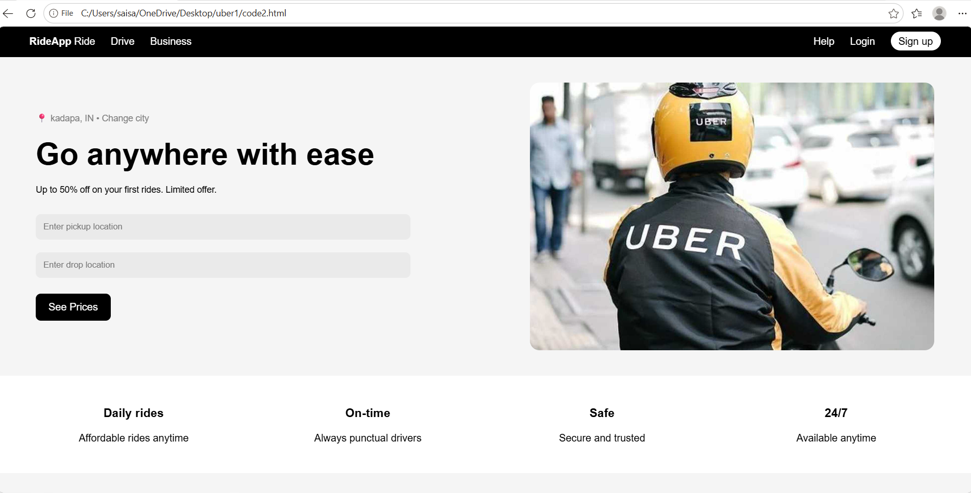

EXPLANATION OF TAGS :
• <!DOCTYPE html>: Defines the document as HTML5.
• <html>: Root element of the webpage.
• <head>: Contains title, styles, and scripts (not visible).
• <meta>: Sets character encoding and makes the page responsive.
• <title>: Displays "Ride UI" in browser tab.
• <style>: Contains all CSS design for layout and UI.
• <script>: Contains JavaScript functions for interactivity.
• <body>: Contains all visible content of the webpage.
• <div>: Used to create sections like navbar, container, features, and modal.
• <span>: Used for small inline items like menu options (Help, Login, etc.).
• <b>: Makes "RideApp" text bold.
• <h1>: Main heading → "Go anywhere with ease".
• <h3>: Used in features and help modal headings.
• <br>: Creates line break between input fields.
• <input>: Used to enter pickup and drop locations.
• <img>: Displays the ride image on the right side.
• onclick: Calls JavaScript functions like:
- openHelp()
- closeHelp()
- login()
- signUp()
- showPrices()

